Toulmin’s Model of Argument

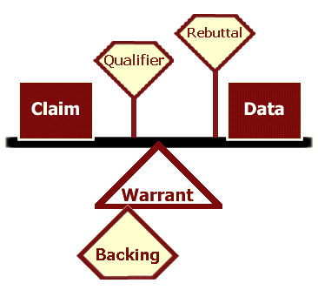
How to use this worksheet:
Toulmin’s model is an effective tool to help you question your sources and the essential elements of your own argument.

Use a separate copy of this worksheet to evaluate each of your sources. Once you’ve identified the specific parts of each argument, compare the claims, the data, the warrants (along with any qualifiers, rebuttals, or backing). Note where arguments are similar or different, weaker or stronger, supported by more or less (or by convincing or unconvincing) data.

Use another copy of the worksheet to plan your own argument. Decide on a claim that is supported by the data and the warrants you have discovered through your research. Knowing the elemental structure of your argument is an essential step toward producing an effective argument.

Source: (Record the full source citation here)_____________________________________ __________________________________________________________________________________________________________________________________________________
List each claim made in the argument.___________________________________________ ____________________________________________________________________________________________________________________________________________________________________________________________________________________________________________________________________________________________________
Record the data used to support each claim.______________________________________ ________________________________________________________________________________________________________________________________________________________________________________________________________________________________________________________________________________________________________________________________________________________________________________________________________________________________________________________________________________________________________________________________________________________________________________________________________
Identify the warrants. (What assumptions make the data support the claims?) Are these warrants implicit (implied) or explicit (clearly stated)?______________________________ ____________________________________________________________________________________________________________________________________________________________________________________________________________________________________________________________________________________________________
Record any backing given for the warrant(s).______________________________________ ____________________________________________________________________________________________________________________________________________________________________________________________________________________________________________________________________________________________________
List any qualifiers.___________________________________________________________ ____________________________________________________________________________________________________________________________________________________________________________________________________________________________________________________________________________________________________
List any rebuttals.___________________________________________________________ ____________________________________________________________________________________________________________________________________________________________________________________________________________________________________________________________________________________________________
What is your overall evaluation of the strength or weakness of this argument? What reasons can you give to support your evaluation?_________________________________________ ____________________________________________________________________________________________________________________________________________________________________________________________________________________________________________________________________________________________________

