Setting the Design Headings on a MAC for a BGS Publishing Style Paper based on the APA 6th Manual

To format a paper for submission in the School of Business and Graduate Studies (BGS) publishing style. The BGS publishing style is firmly rooted in the American Psychological of Association’s 6th edition publication style manual known as APA6th. It is very helpful to make some adjustments to the MS word Design Heading settings. These design headings effect the style of every aspect of the paper and taking the time to set these in advance it will save you much time in editing and formatting later in the draft and revision process.
There are many benefits to setting your design headings beyond formatting. First among these is that these settings will be based on APA Normal, which means you will not have to worry if your Normal paragraph changes in other documents. Just as important is that your captions for tables and figures will match your document. And most important is that you can add a table of contents based on the first and second level headings (APA Heading 1 and APA Heading 2). It is recommended that you do not change any design headings you might want to use in your other everyday documents. Instead save them to a new quick style.
In this document you will learn how to setup the following design headings: APA Normal, APA Heading 1 for chapter headings; APA Heading 2 for section headings within the chapter; Title for the title page; Abstract for the abstract paragraph; APA References for the references list; Quote for block quotes; List Paragraph for bulleted lists; Caption for the labels on Tables and Figures; TOC 1 for the table of contents chapter entries, and TOC 2 for the section level headings.
The design headings are found above the menus or from the Format menu choose Styles in MS Word for MAC. They are small squares with white backgrounds or a list if you use Format – Styles.. As you can see Microsoft has many preset for use in writing and formatting papers, however they do not meet the BGS or APA 6th style requirements. This example describes how to and shows screen shots using MS Word 2011 on a MAC.
The Process works best if you start with Normal and follow through to the last item in the Table of Contents.

Table of Contents
Page
Setting the Normal Paragraph 2
Setting the Heading 1 4
Setting the Heading 2 5
Additional Design Headings 7
To Set the Title Page 7
To Set the Block Quote 8
To Set the List Paragraph 9
To Set the Caption 10
To Set the References 11
To Set Table of Contents Heading (TOC Heading) 12
To Set Table of Contents 1 (TOC1) 13
To Set Table of Contents 2 (TOC2) 14
To Insert the Table of Contents Page 16

Setting the Normal Paragraph
Right click on Normal in the design headings and choose Modify
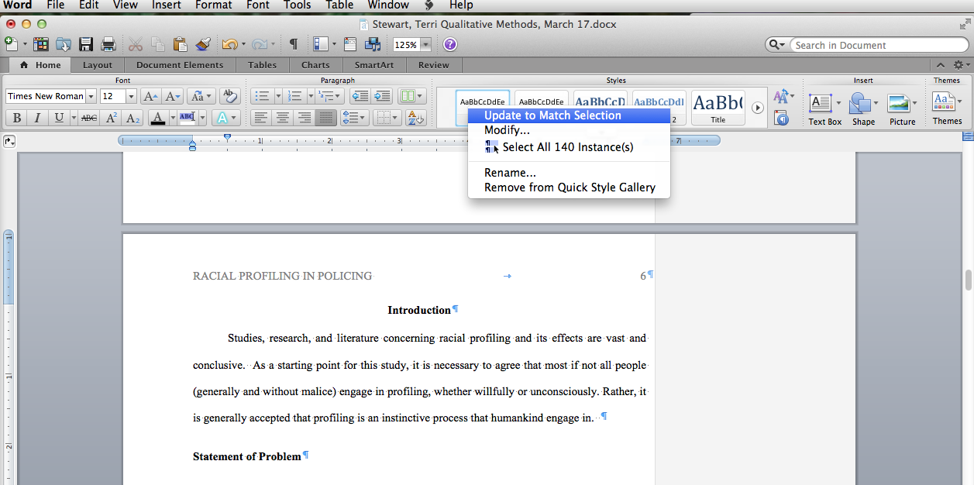

Set the font to Times New Roman 12 pt with no bold or italic, a Justified paragraph, and double-spaced lines.
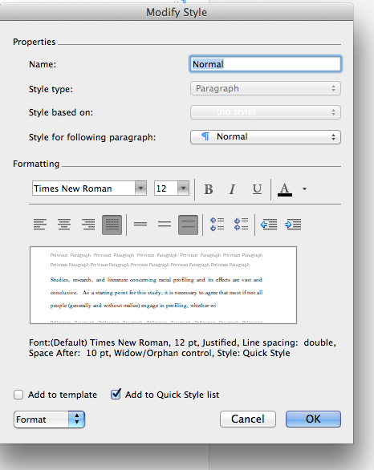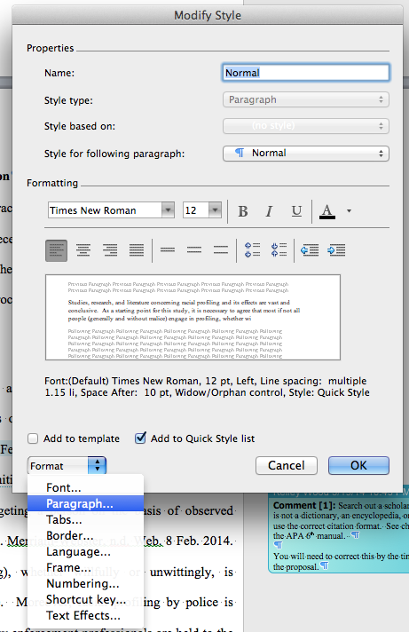

Then choose to format the Paragraph within the Normal style window. Change Outline Level from Body text to Level 1. Set the Indent for the first line of the Paragraph under Special: First Line, By 0.5”. Check that only the Window/Orphan control is checked on the Line and Page Break tab of the Paragraph window. And click to accept your changes
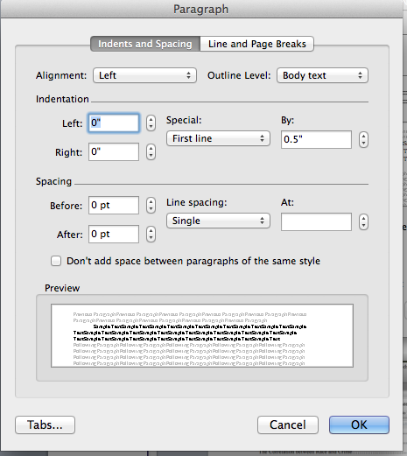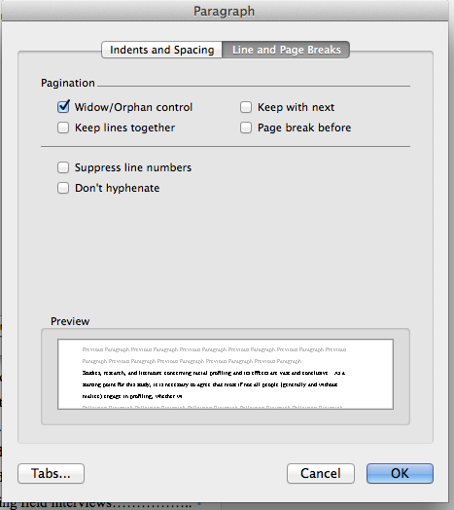

Setting the Heading 1
Right click on Heading 1 and choose Modify
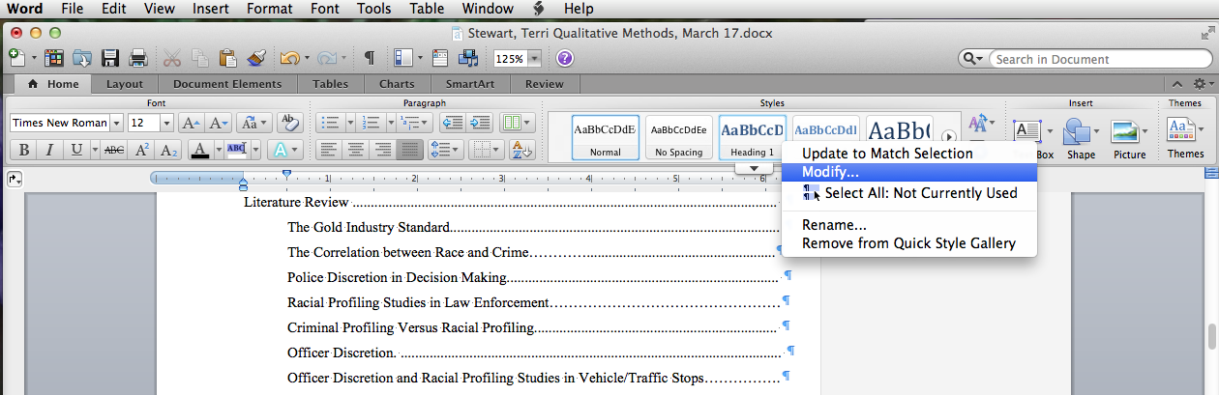

Set the font to Times New Roman 12 pt with bold, a centered paragraph, double-spaced lines, and be sure the font uses the Automatic Ink color for black lettering. Finaly, check the Add to Quick Style list and the Automatically Update boxes.
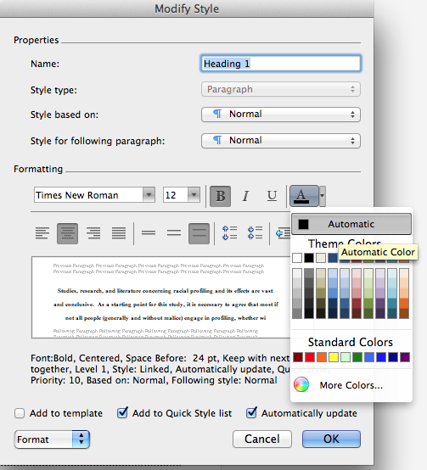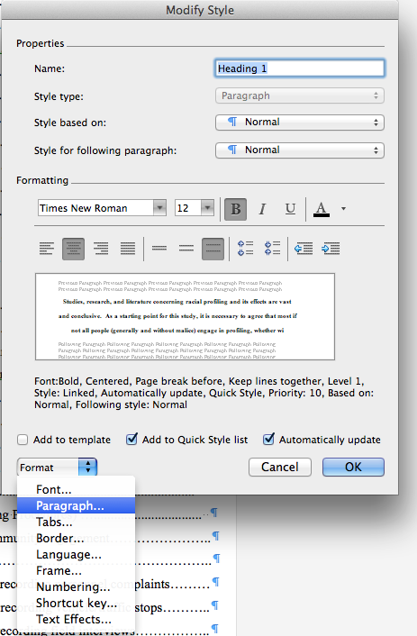

Then chose to format the Paragraph within the Heading 1 style and also the Line and Page Break tab in the Paragraph style. Be sure to check Keep Lines Together and Page break before. This is really important! And click to accept your changes
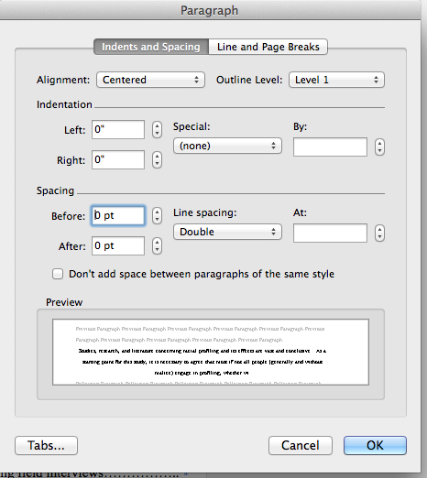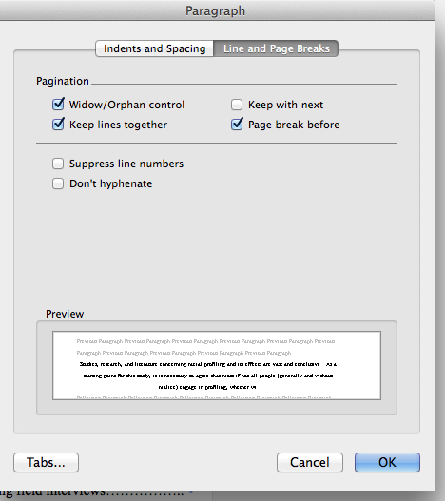

Setting the Heading 2
This is much like setting the Heading one, with some key differences so please be careful! Right click on Heading 2 and choose Modify.

Set the font to Times New Roman 12 pt with bold, a Left margin paragraph, double-spaced lines, and be sure the font uses the Automatic Ink color for black lettering. Finaly, check the Add to Quick Style list and the Automatically Update boxes.
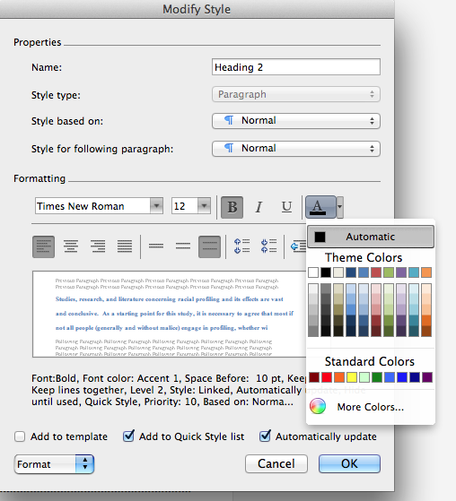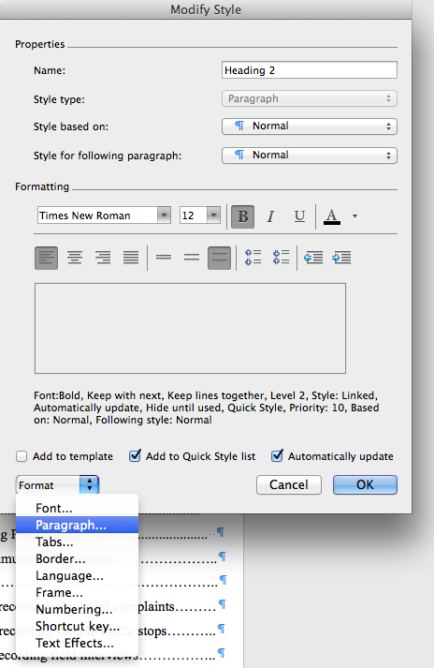

Then chose to format the Paragraph within the Heading 2 style and also the Line and Page Break tab in the Paragraph style. Change the Outline Level to Level 2. Be certain to check Keep with Next and Keep Lines Together. This is really important! And click to accept your changes
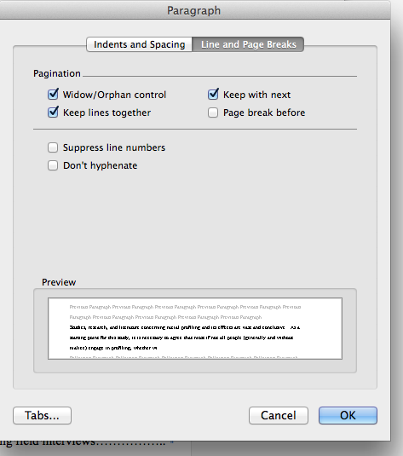

Additional Design Headings
To accomplish the following setting changes you will need to open the Manage Style Menu, which is just to the right of the Design Headings. The icon is a small page with a paragraph icon (like a backward P). Be sure to select List: All Styles.
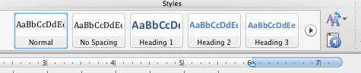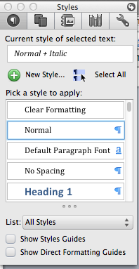

To Set the Title Page
Scroll down the styles to Title and then as you hover over the right side of the Title style you can click a drop down and choose to Modify Style. Then choose to Format the paragraph style.
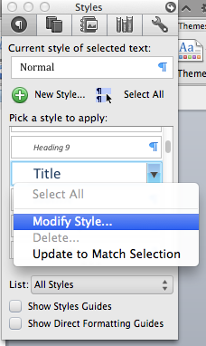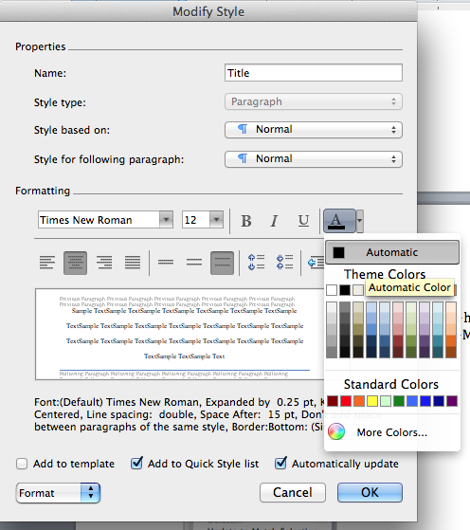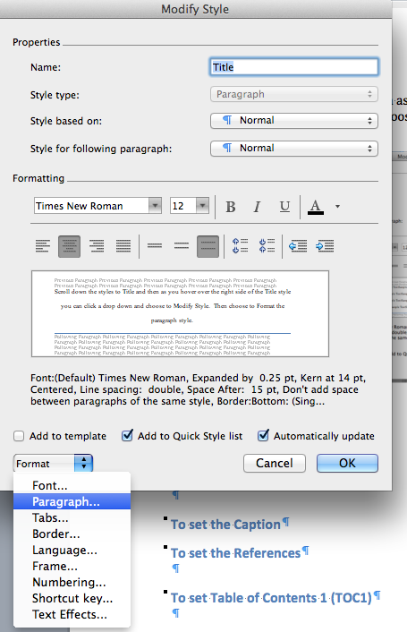
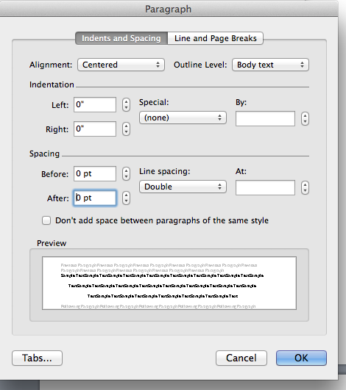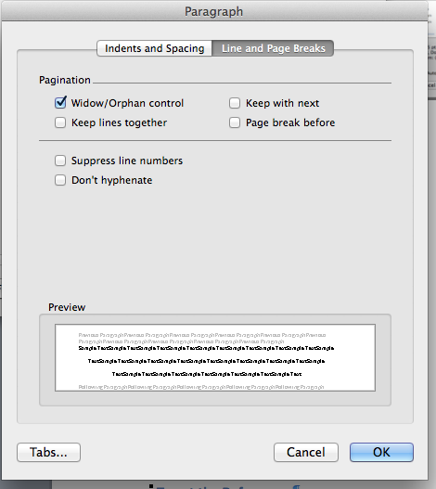

To Set the APA Block Quote
There are some important differences in the Bock Quote. They are indented from both margins, do not indent, and can be set at 1.5 lines.
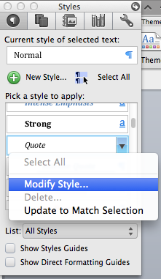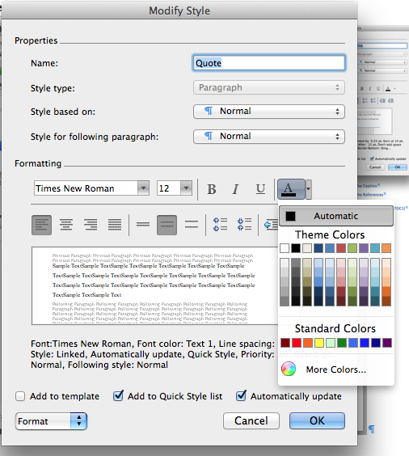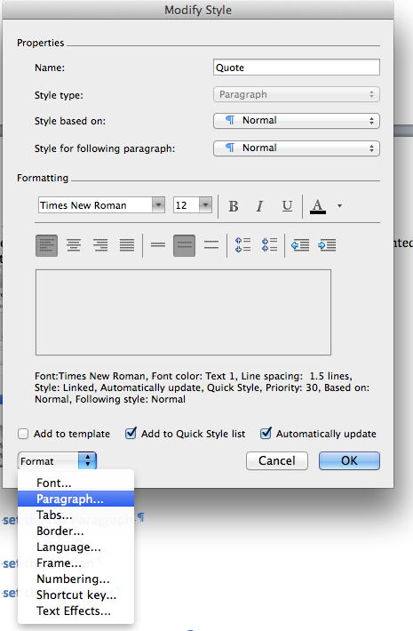

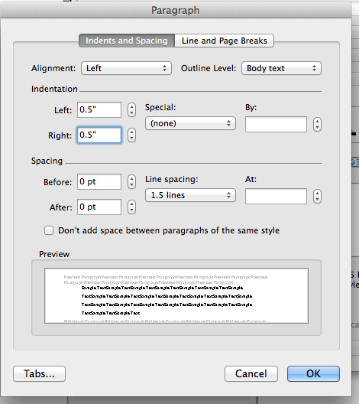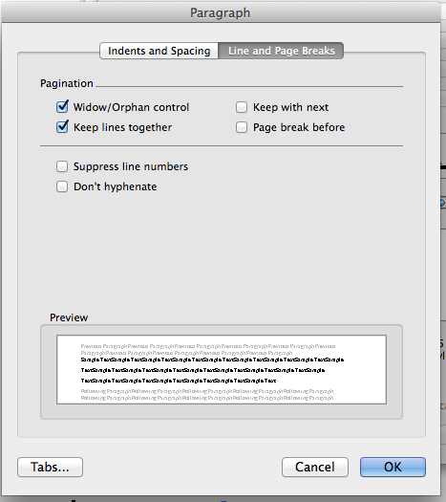

To Set the List Paragraph for Bulleted Lists
This is much like the Block Quote, but sets the Bulleted or Numbered List. After you set List, set List Bullet in the same manner.
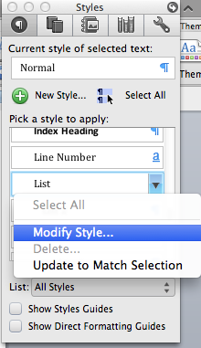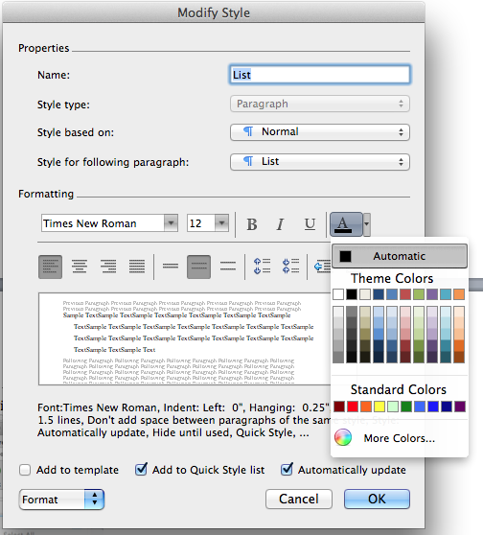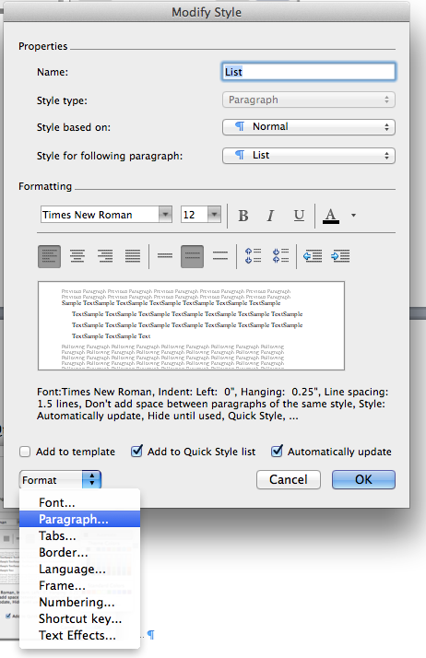

To Set the Caption
The caption is like Normal. However it is Left Margin. You will need to manually modify the Table Caption and the Figure Caption to be italicized in the right part of the caption.
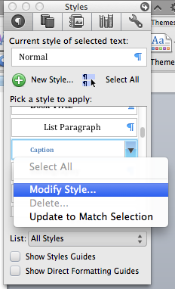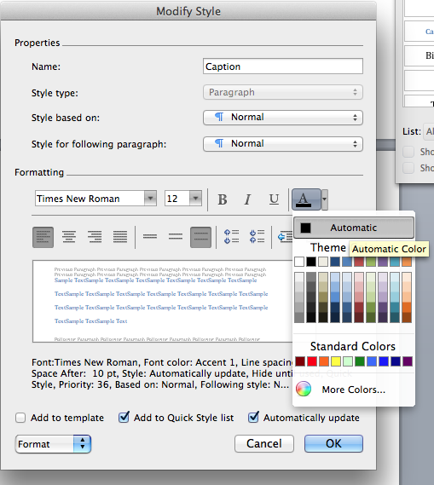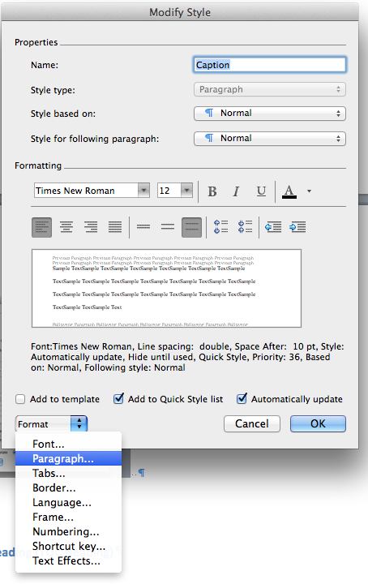

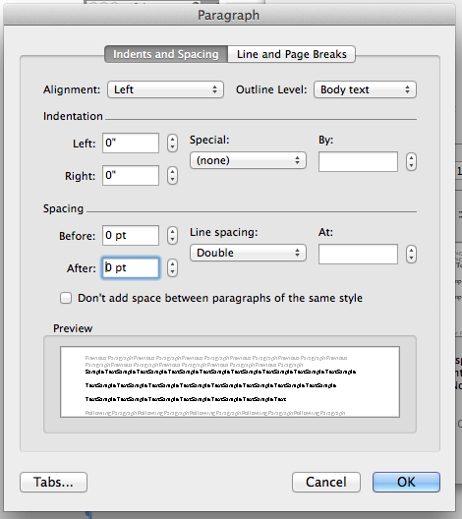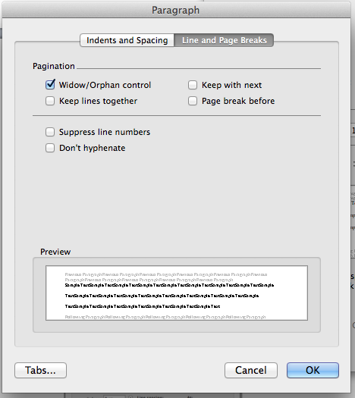

To Set the References
This is different in that you will need to create a new style! It is easy. On the Styles Menu click the New Style icon (green circle with a white plus sign). Be sure to name this one References. Remember this is hanging indent and can be set to 1.5 line spaces. Occasionally a reference will not format correctly in Justified margin. To prevent this use Left margin. Additionally set the Lines and Breaks to keep lines together so the reference stays together on a page.
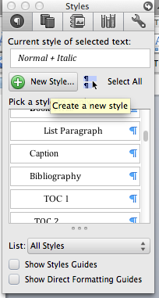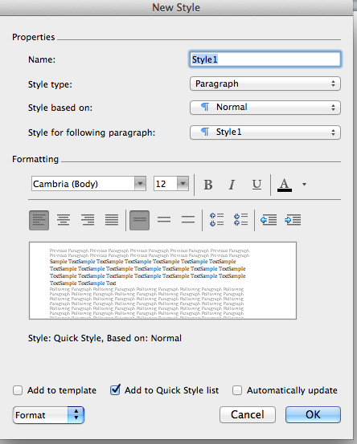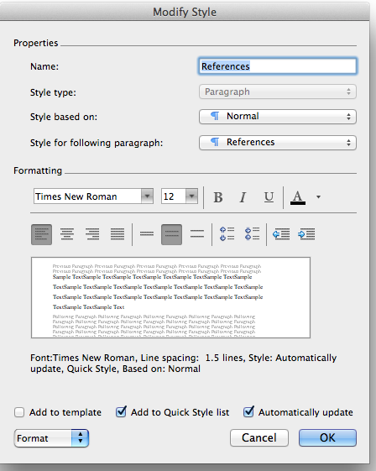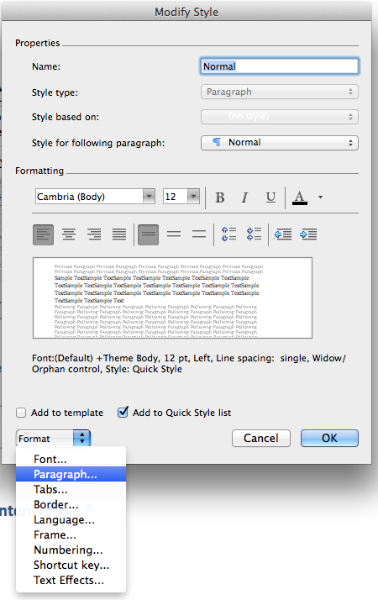

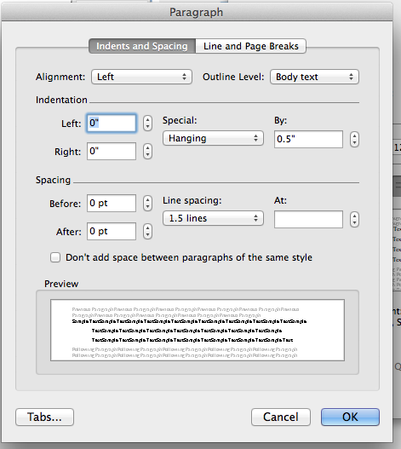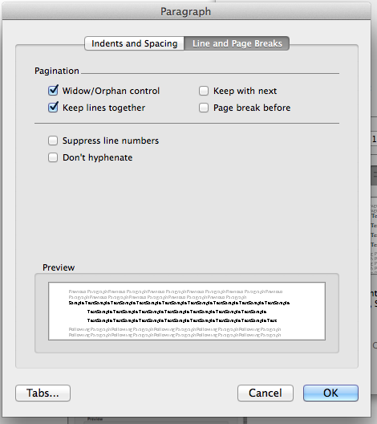

To Set Table of Contents Heading (TOC Heading)
This heading is like the Title page. Centered, not bold Times New Roman 12 pt., but has 1.5 spaced lines. The following settings will establish the table of contents lines within the TOC.
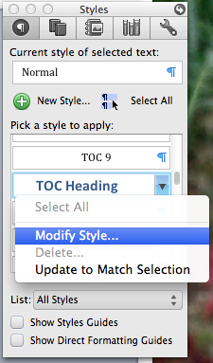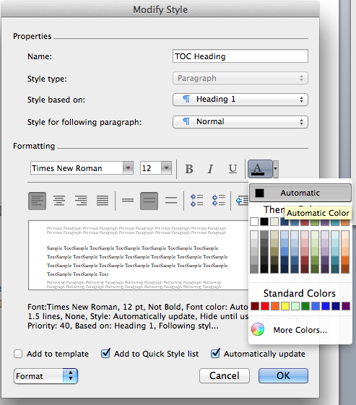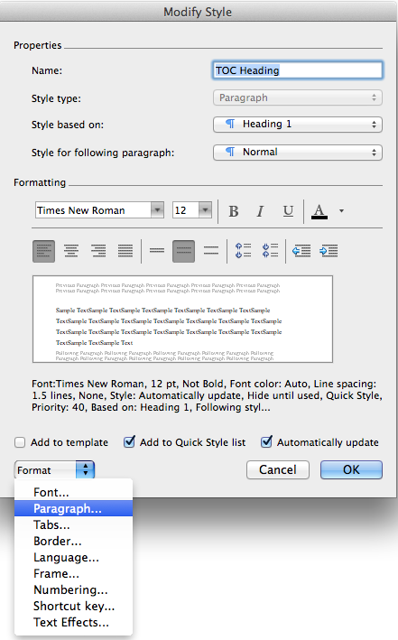

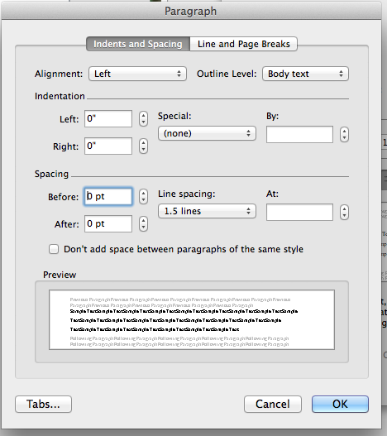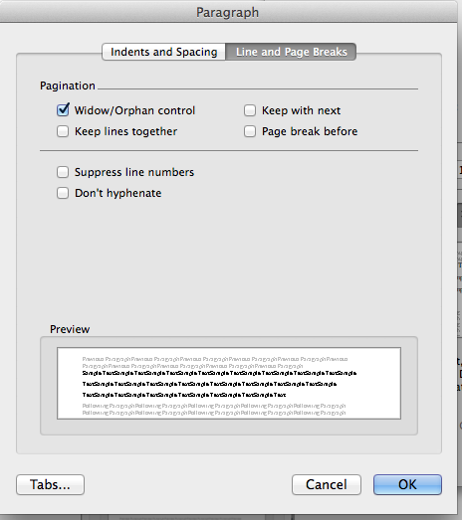

To Set Table of Contents 1 (TOC1)
The TOC headings 1 is for the chapter level design heading and requires an additional set of steps to establish the page number with a right tab and the leader periods. It is not difficult! There is an important addition to the first TOC heading. They are indented and you use both Keep Lines Together and Keep with Next!
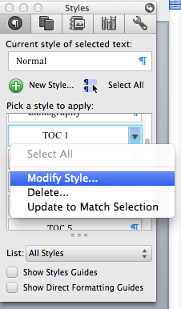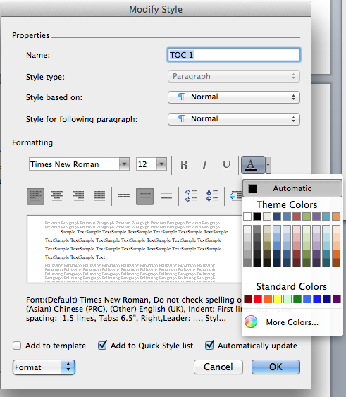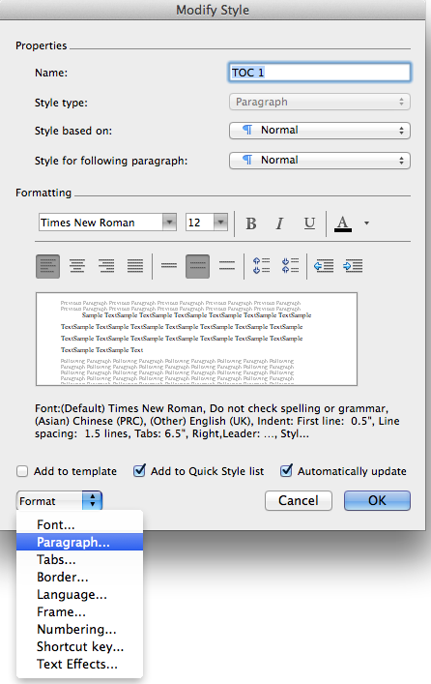

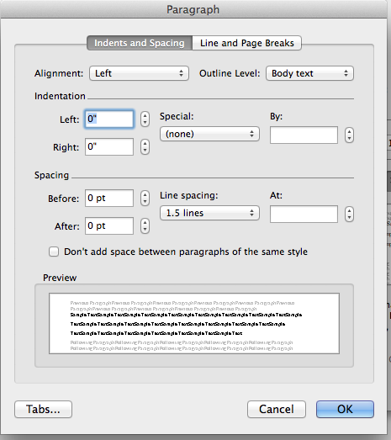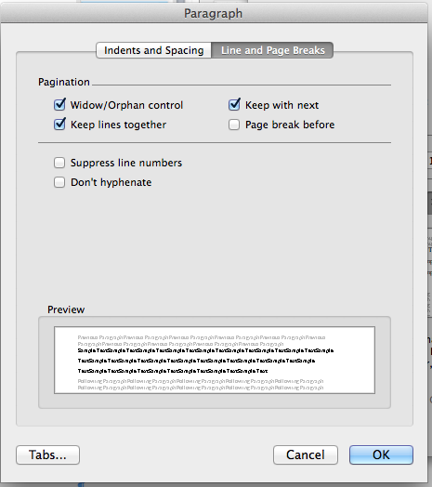

To Set Table of Contents 2 (TOC2)
There are some important differences between the first and second TOC headings. First they are indented and you use Keep Lines Together, but not Keep with Next!.
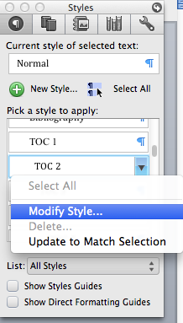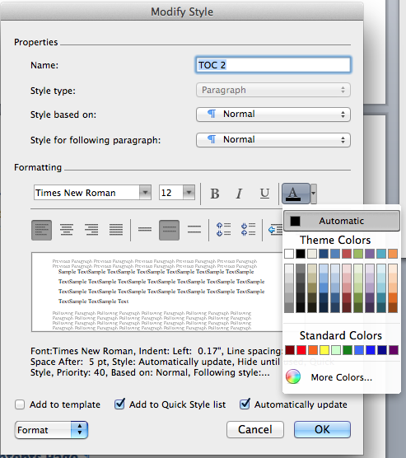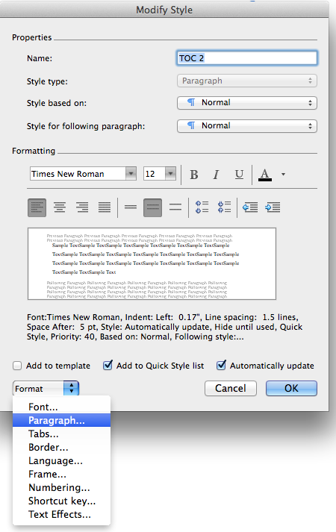

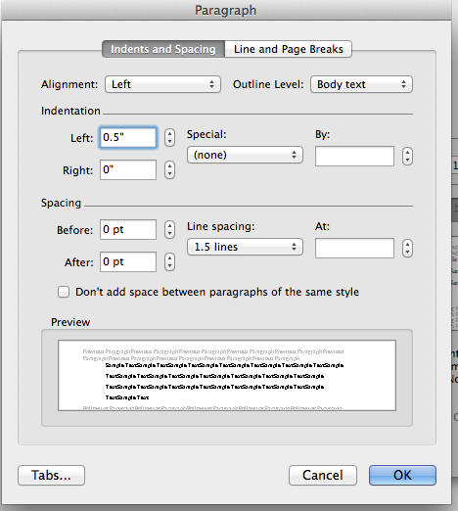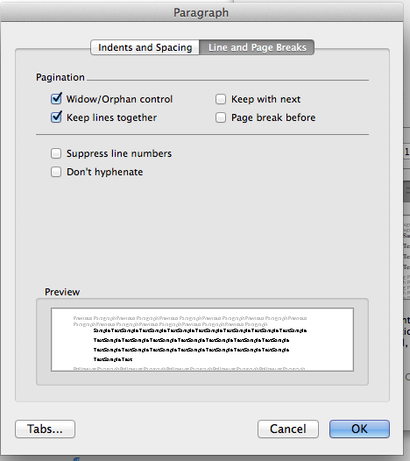

Then for the Tab there are two ways to get there.

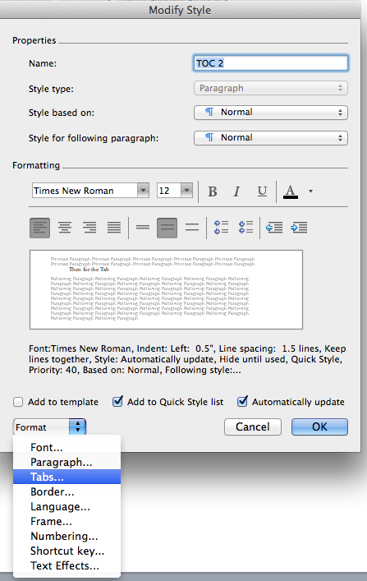 or 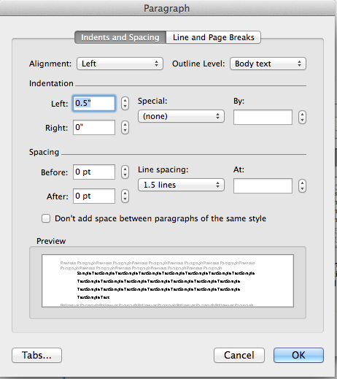

Enter the tab of 6.5, make it right, and check the period leader. Then click SET and OK.
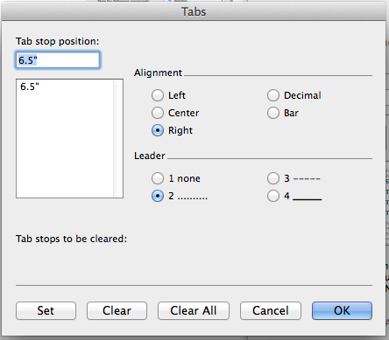

To Insert the Table of Contents Page
To finalize the SPS & APA settings for the paper you will need to set up the table of contents. It is easiest to do this once you have some headings in your document. Move to the page where you will insert the Table of Contents (TOC), just after the Abstract and just before the Introduction. Choose to insert Index and Tables from the Insert menu.
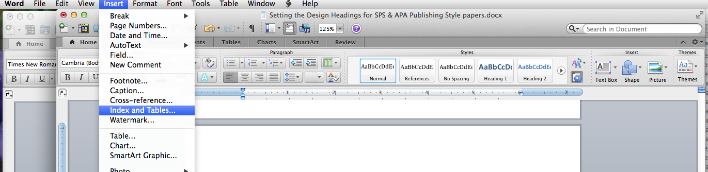

Then on the Table of Contents tab of the Index and Tables menu choose from template, Show levels: 2, Show page numbers, and Right align page numbers. Then click OK. Since you set the TOC headings this will insert a perfect table of contents. You will need to add a right Margin Page heading.
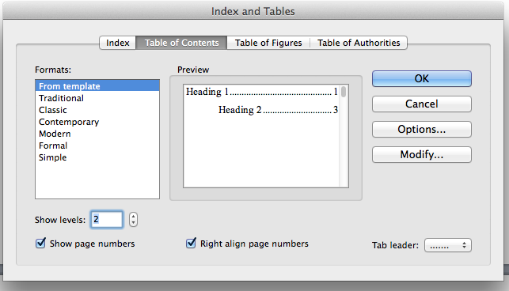

As a bonus you now that your TOC is set in the Indexes and Tables menu the List of Tables and List of Figures will follow suit to be formatted in the same manner! Use the Table of Figures tab and choose Tables or Figures to insert the correct list. See a table of contents on the first page of this document.

