Setting the Design Headings on a MAC for a BGS Publishing Style Paper based on the APA 6th Manual

To format a paper for submission in the School of Business and Graduate Studies (BGS) publishing style. The BGS publishing style is firmly rooted in the American Psychological of Association’s 6th edition publication style manual known as APA6th. It is very helpful to make some adjustments to the MS word Design Heading settings. These design headings effect the style of every aspect of the paper and taking the time to set these in advance it will save you much time in editing and formatting later in the draft and revision process.
There are many benefits to setting your design headings beyond formatting. First among these is that these settings will be based on APA Normal, which means you will not have to worry if your Normal paragraph changes in other documents. Just as important is that your captions for tables and figures will match your document. And most important is that you can add a table of contents based on the first and second level headings (APA Heading 1 and APA Heading 2). It is recommended that you do not change any design headings you might want to use in your other everyday documents. Instead save them to a new quick style.
In this document you will learn how to setup the following design headings: APA Normal, APA Heading 1 for chapter headings; APA Heading 2 for section headings within the chapter; Title for the title page; Abstract for the abstract paragraph; APA References for the references list; Quote for block quotes; List Paragraph for bulleted lists; Caption for the labels on Tables and Figures; TOC 1 for the table of contents chapter entries, and TOC 2 for the section level headings.
The design headings are found on the home ribbon (tab) in MS Word. They are small squares with white backgrounds on the right side of the ribbon. As you can see Microsoft has many preset for use in writing and formatting papers, however they do not meet the BGS or APA 6th style requirements. This example describes how to and shows screen shots using MS Word 2010 on a PC.

Table of Contents
Page
To Set APA Normal 3
To Set APA Heading 1 4
To Set APA Heading 2 6
Additional Design Style Headings 7
To Set the Title Page 7
To Set The Abstract paragraph 8
To Set The APA References List 8
To Set The APA Block Quote 9
To Set List Paragraph 9
To set the Caption 10
To Set TOC 1 for the Table of Contents Chapter Entries. 11
To Set TOC 2 for the Section Level Headings 13
To Insert the Table of Contents 14

To Set APA Normal
First it is necessary to establish the normal paragraph in APA style. With your cursor on a new line change the paragraph by setting your font to Times New Roman 12pt. Then use the Paragraph tool to set the line spacing. The Paragraph tool is an icon just over the word paragraph on the Home ribbon. It shows a series of lines and arrows pointing up and down. You will use this tool often in this process.
Pull down on the icon and choose Line Spacing Options and the Paragraph Menu opens.
Change the paragraph settings to match the first print screen of the paragraph tool and check to see that the Line and Page Break tab is set with only the Window/Orphan control checked.

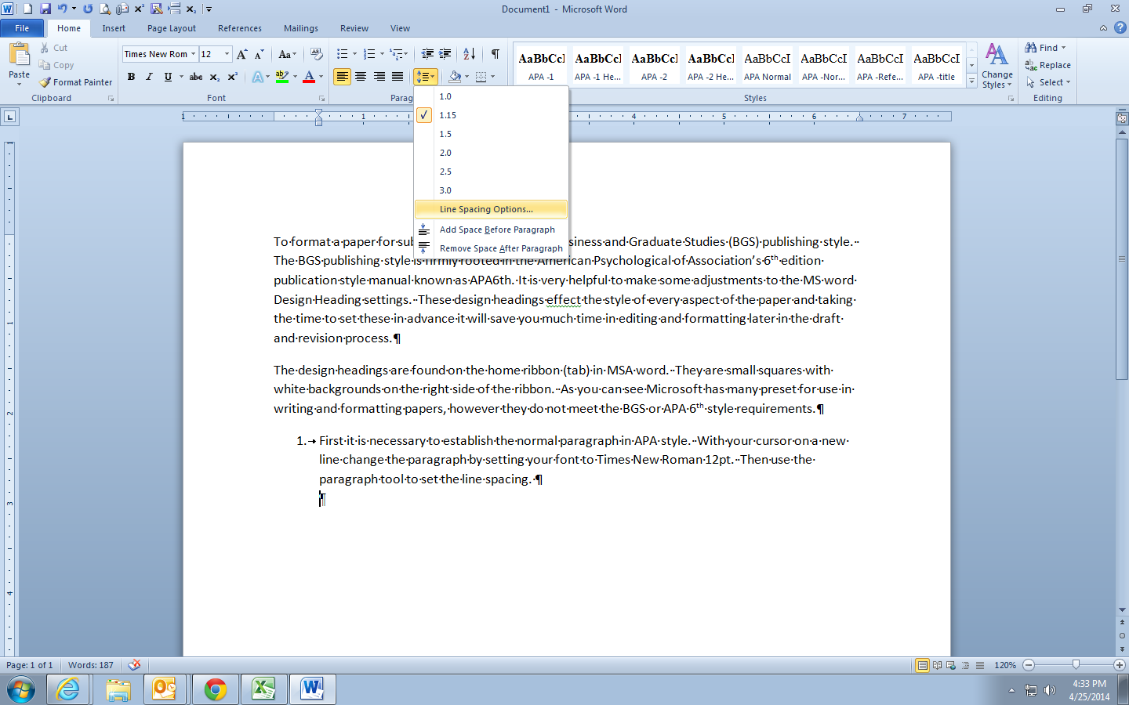

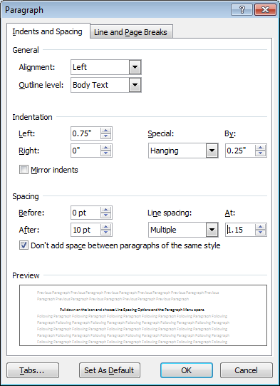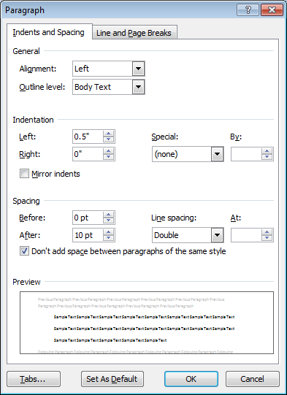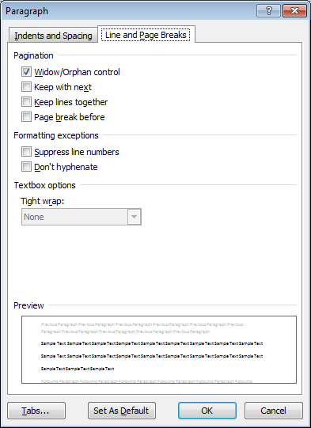

Now establish this as APA Normal by expanding the design headings settings and choosing Save Style a New Quick Style. Name the quick style APA Normal and save.
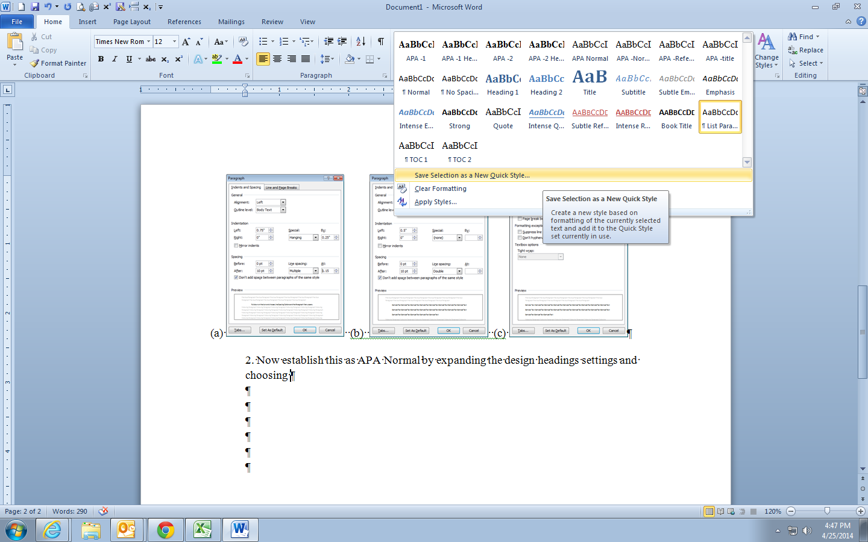

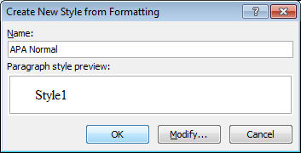

Now you can begin setting up the headings and many more design headings that will control your paper.
The headings set in this document are APA Heading 1 for chapter headings; APA Heading 2 for section headings within the chapter; Title for the title page; Abstract for the abstract paragraph; APA References for the references list; Quote for block quotes; List Paragraph for bulleted lists; Caption for the labels on Tables and Figures; TOC 1 for the table of contents chapter entries, and TOC 2 for the section level headings.

To Set APA Heading 1
On a new line that is already set to APA Normal click bold and center the line, then open the paragraph tool to make the following adjustments.
No indents, no spaces before or after, doubles spaced, and on the lines and page break tab click Window/Orphan and Page Break Before (this will keep your chapter headings at the top of a new page.
Now expand the Quick Style menu and choose to Save Style as a New Quick Style. Name this APA – Heading 1 and save.

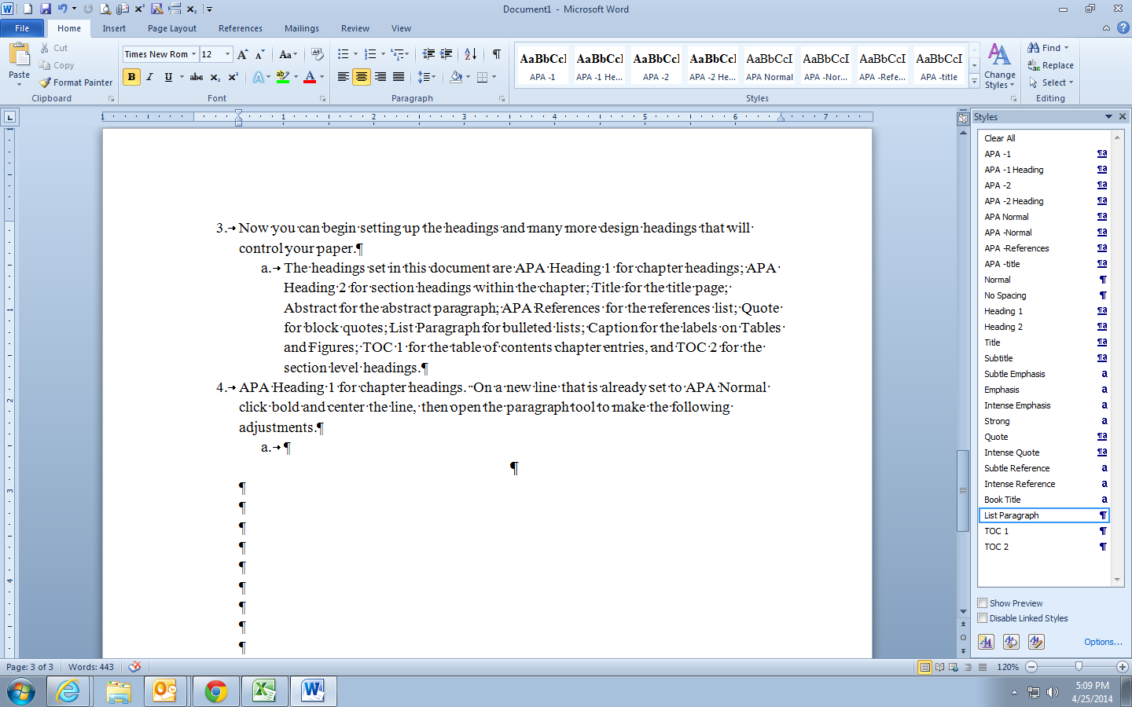

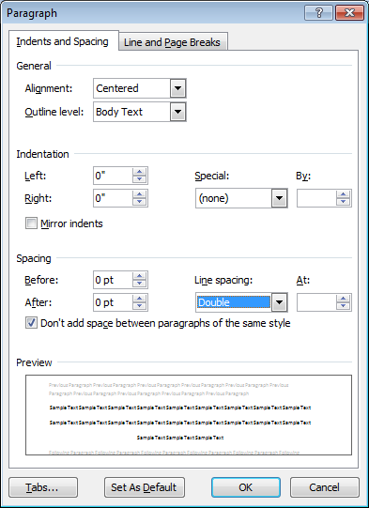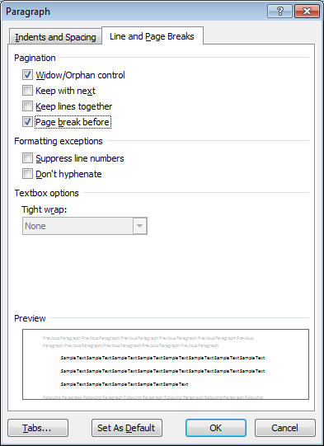

To Set APA Heading 2
On a new line set the margin to the left, click bold and open the paragraph tool to make the following adjustments.
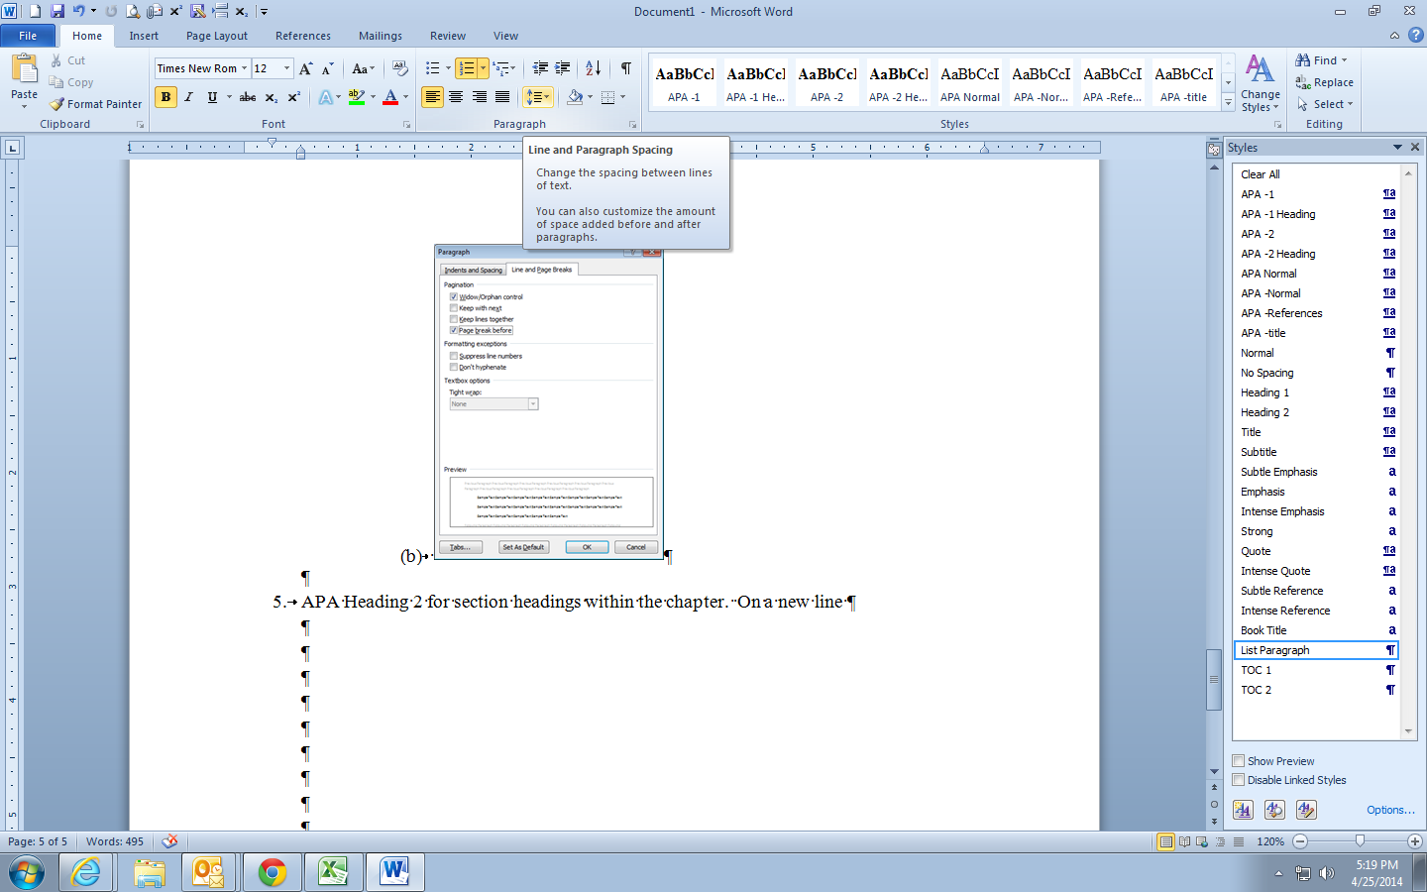

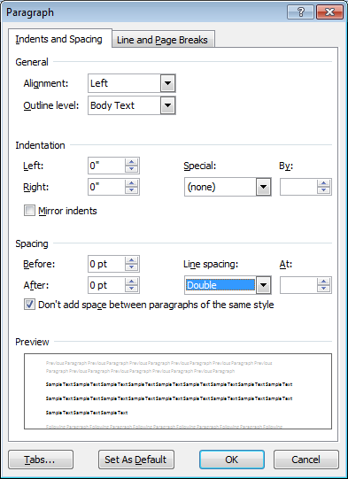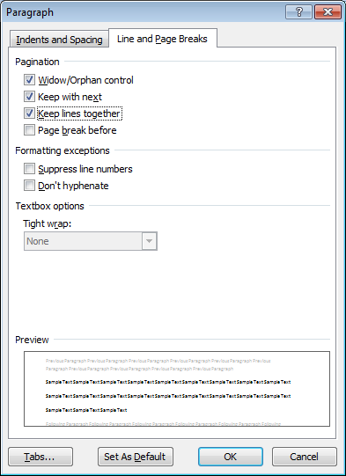

The use of Keep with next and Keep lines together will prevent sections from being orphaned at the end of the page or titles from being split between two pages.
Now expand the Quick Style menu and choose to Save Style as a New Quick Style. Name this APA – Heading 2 and save.

These are the basics and know you know the pattern: set a new line to the requirements of your New Quick Style. Then Save Style as a New Quick Style. Following this pattern has many benefits. First among these is that these settings will be based on APA Normal, which means you will not have to worry if your Normal paragraph changes in other documents. Just as important is that your captions for tables and figures will match your document. And most important is that you can add a table of contents based on the first and second level headings (APA Heading 1 and APA Heading 2). It is recommended that you do not change any design headings you might want to use in your other everyday documents. Instead save them to a new quick style.

To complete the setup of your paper please set your paragraphs and save the following design headings: Title for the title page; Abstract for the abstract paragraph; APA References for the references list; APA Quote for block quotes; List Paragraph for bulleted lists; Caption for the labels on Tables and Figures; TOC 1 for the table of contents chapter entries, and TOC 2 for the section level headings.

Additional Design Style Headings

To Set the Title Page
On a new line set your font to 12 pt. Times New Roman, Centered, and double-spaced. Then set your paragraphs to match the screenshots below. Last, save and name the new Quick Style as APA Title.
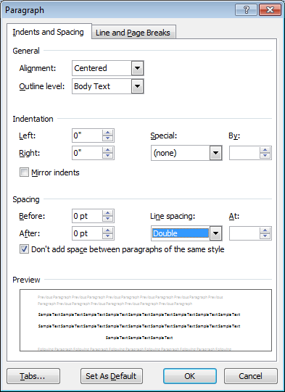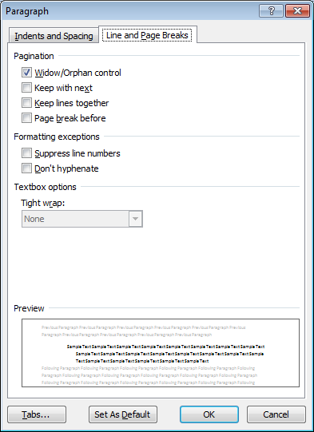

To Set the Abstract Paragraph
On a new line set your font to 12 pt. Times New Roman, Justified, and double-spaced. Then set your paragraphs to match the screenshots below. Last, save and name the new Quick Style as APA Abstract.
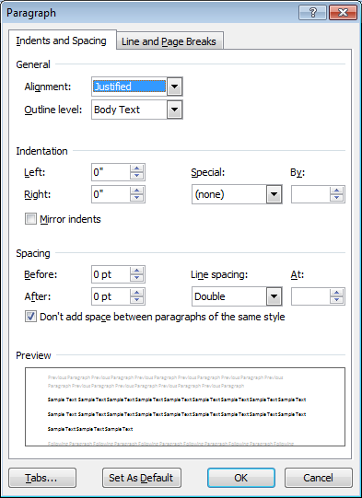

To Set the APA References List
On a new line set your font to 12 pt. Times New Roman, left margin, and 1.5 spaced. Then set your paragraphs to match the screenshots below. Last, save and name the new Quick Style as APA References. These setting make the references easier to read and keep full references together.
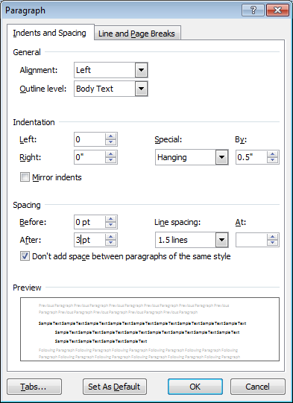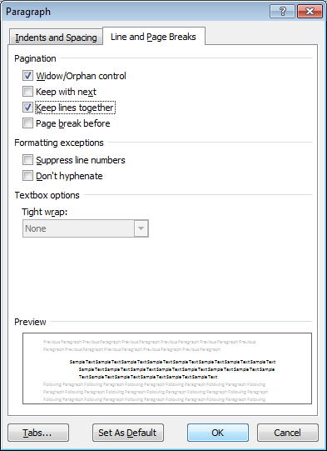

To Set the APA Block Quote
On a new line set your font to 12 pt. Times New Roman, Justified, and 1.5 spaced. Then set your paragraphs to match the screenshots below. Last, save and name the new Quick Style as APA Quote. These setting make the block quote easier to read.
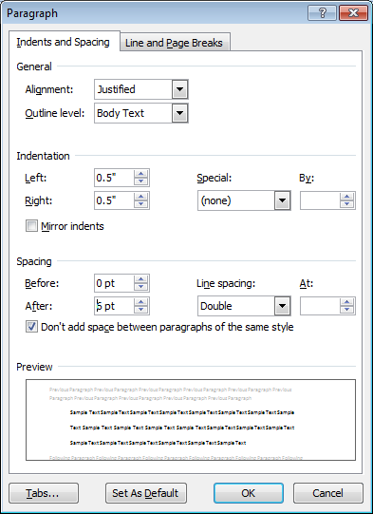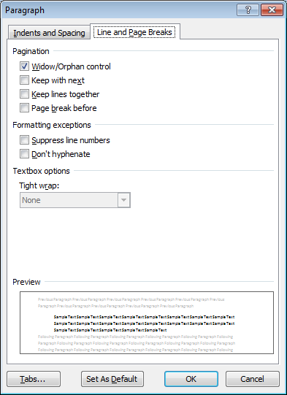

To Set the List Paragraph for Bulleted Lists
On a new line set your font to 12 pt. Times New Roman, Justified, and 1.5 spaced. Then set your paragraphs to match the screenshots below. Last, right click on the Quick Style, List Paragraph in the design headings or the styles menu, and choose to Update Paragraph to Match Selection. These setting make the bulleted or numbered list easier to read.
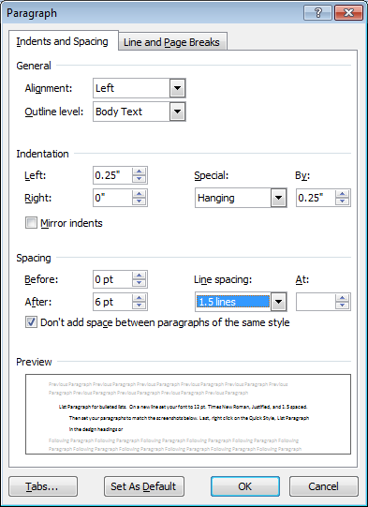

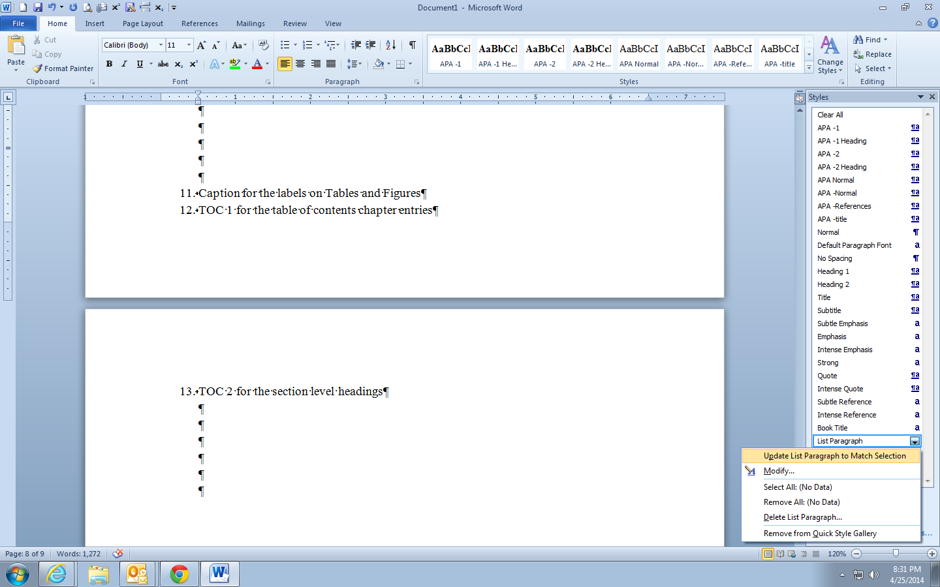

To set the Caption
On a new line set your font to 12 pt. Times New Roman, Justified, and 1.5 spaced. Then set your paragraphs to match the screenshots below. Last, right click on the Quick Style, Captions in the design headings or the styles menu, and choose to Update Paragraph to Match Selection. These setting make the captions above your tables and the captions below your figures easier to read.
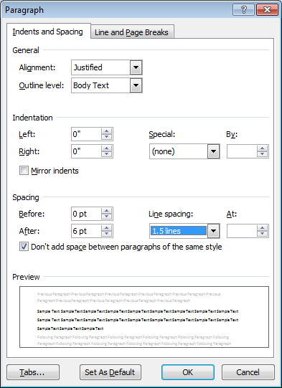
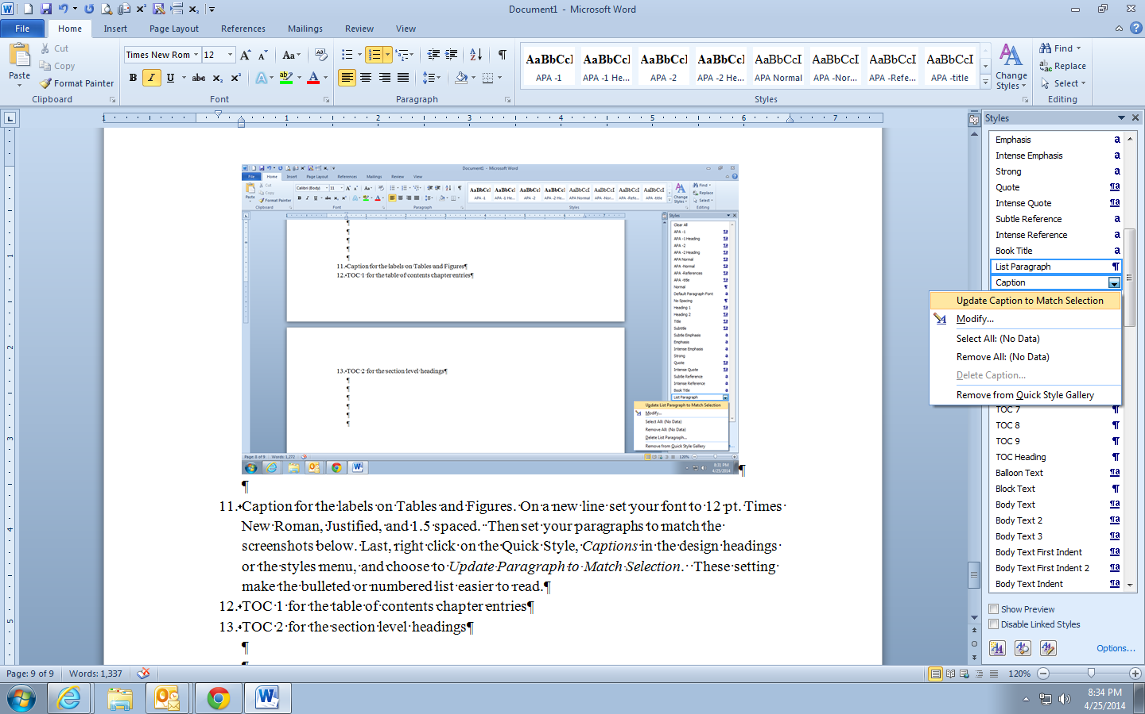

To Set TOC 1 for the Table of Contents Chapter Entries.
On a new line right click on the Quick Style, TOC 1 in the design headings or the styles menu, and choose to Modify. Match your Modify screens to those below. Use the Format button to get to Paragraphs and to Tabs. Set the tab to 6.5, Right, and use the period leader. Note that the paragraph has no indent. The use of Keep with Next will ensure that the chapter listing is not orphaned at the bottom of the page, but moves to the next page with its contents. These setting make the table of contents appear more professional and easier to read.
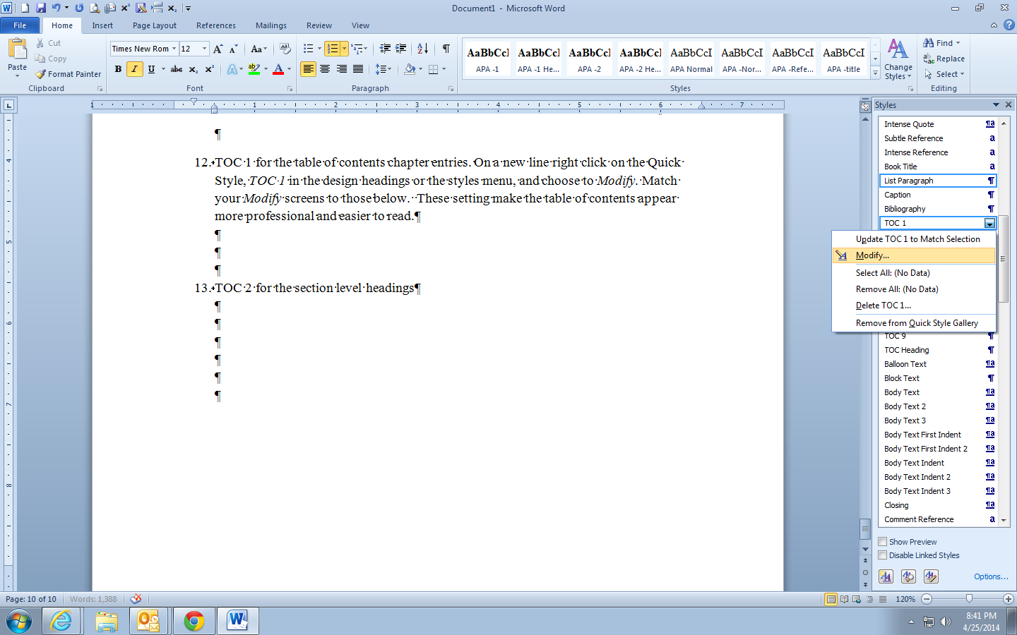
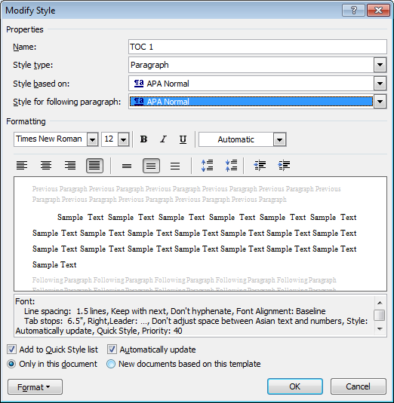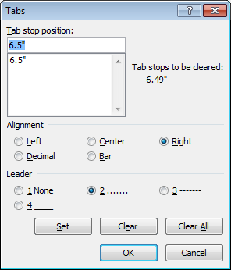

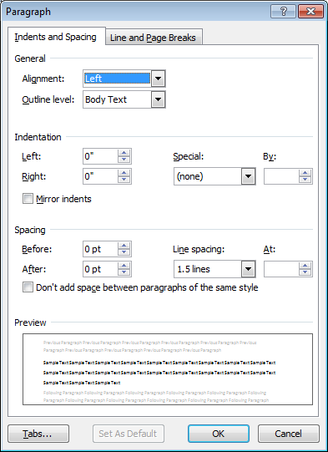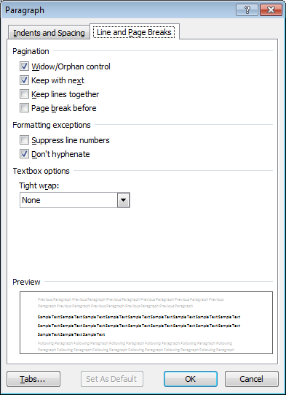

To Set TOC 2 for the Section Level Headings
On a new line right click on the Quick Style, TOC 2 in the design headings or the styles menu, and choose to Modify. Match your Modify screens to those below. Use the Format button to get to Paragraphs and to Tabs. Set the tab to 6.5, Right, and use the period leader. Not that the paragraph has a 0.5 left indent. The use of Keep with Next will ensure that the chapter listing is not orphaned at the bottom of the page, but moves to the next page with its contents. These setting make the table of contents appear more professional and easier to read.
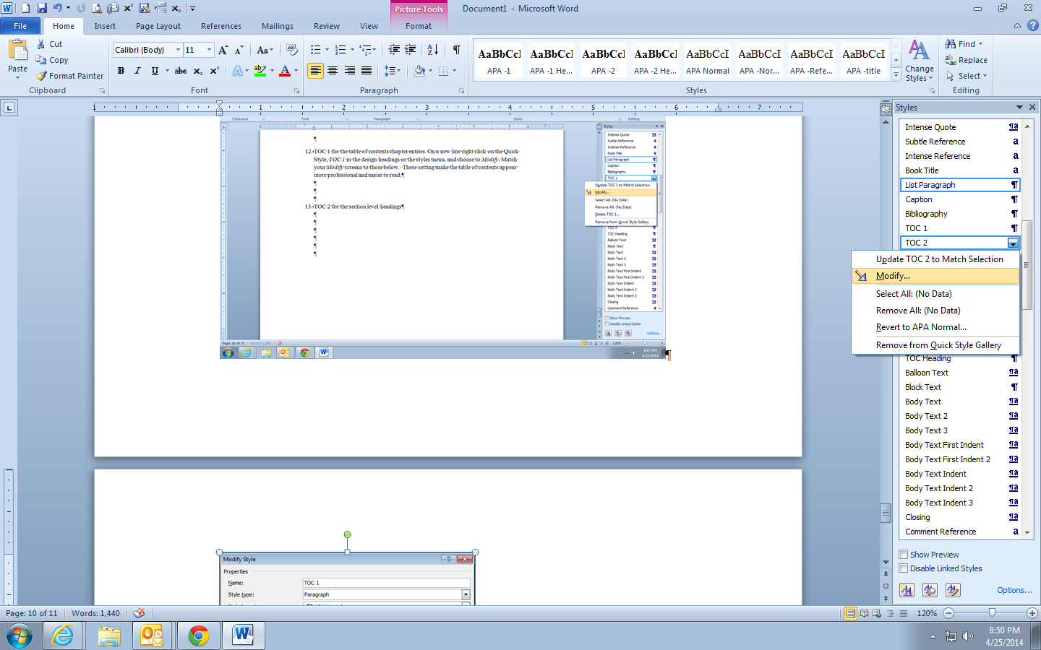

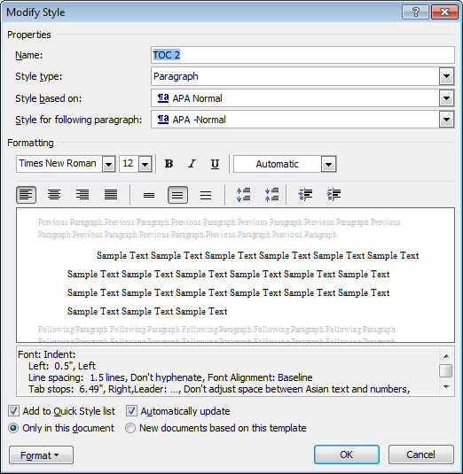

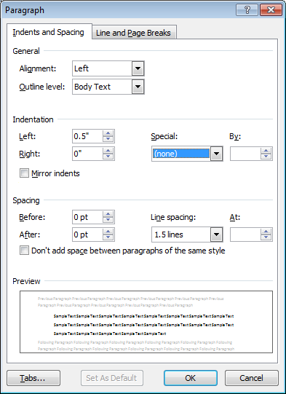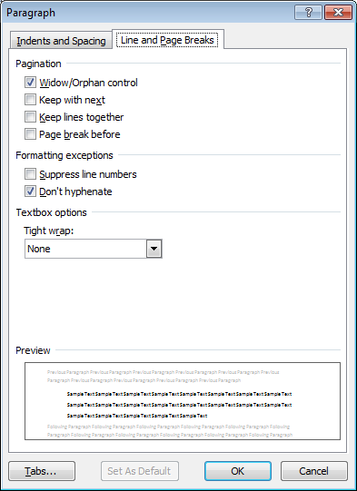

To Insert the Table of Contents
On the next new page after the Abstract, type Table of Contents and click APA Title, and then enter for the nest line. Type Page and make it right margin, then Enter. Now go to the References ribbon (tab) and click Table of Contents Menu (on the left). Choose Insert Table of Contents… Now change to show two (2) levels and check that the boxes for Show page numbers and Right align page numbers, and Tab leaders are periods. Then click OK. This will populate the table of contents. It should be perfect if the APA Normal, APA Heading 1, APA Heading 2 are assigned correctly.

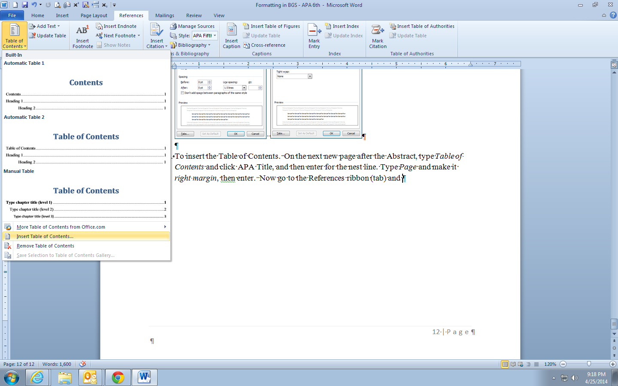

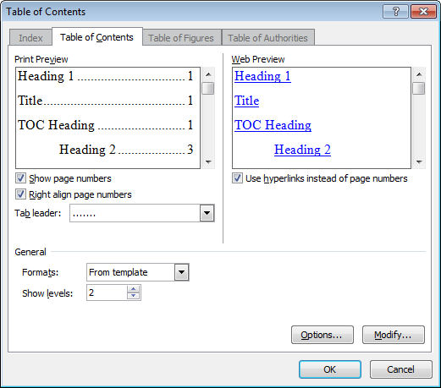

As a bonus you now that your TOC is set in the Indexes and Tables menu the List of Tables and List of Figures will follow suit to be formatted in the same manner! Use the Table of Figures tab and choose Tables or Figures to insert the correct list. See a table of contents on the first page of this document.

