CONCUSSION
SAFETY

WHAT STUDENT-ATHLETES
NEED TO KNOW

What is a concussion?
A concussion is a type of traumatic brain injury. It follows a force to the head or body and leads to a change in brain function. It is not typically accompanied by loss of consciousness.

How can I keep myself safe?
1. Know the symptoms.
You may experience …
- Headache or head pressure
- Nausea
- Balance problems or dizziness
- Double or blurry vision
- Sensitivity to light or noise
- Feeling sluggish, hazy or foggy
- Confusion, concentration or memory problems

2. Speak up.
- If you think you have a concussion, stop playing and talk to your coach, athletic trainer or team physician immediately.

3. Take time to recover.
- Follow your team physician and athletic trainer’s directions during concussion recovery. If left unmanaged, there may be serious consequences.
- Once you’ve recovered from a concussion, talk with your physician about the risks and benefits of continuing to participate in your sport.
How can I be a good teammate?
1. Know the symptoms.
You may notice that a teammate …
- Appears dazed or stunned
- Forgets an instruction
- Is confused about an assignment or position
- Is unsure of the game, score or opponent
- Appears less coordinated
- Answers questions slowly
- Loses consciousness

2. Encourage teammates to be safe.
- If you think one of your teammates has a concussion, tell your coach, athletic trainer or team physician immediately.
- Help create a culture of safety by encouraging your teammates to report any concussion symptoms.

3. Support your injured teammates.
- If one of your teammates has a concussion, let him or her know you and the team support playing it safe and following medical advice during recovery.
- Being unable to practice or join team activities can be isolating. Make sure your teammates know they’re not alone.

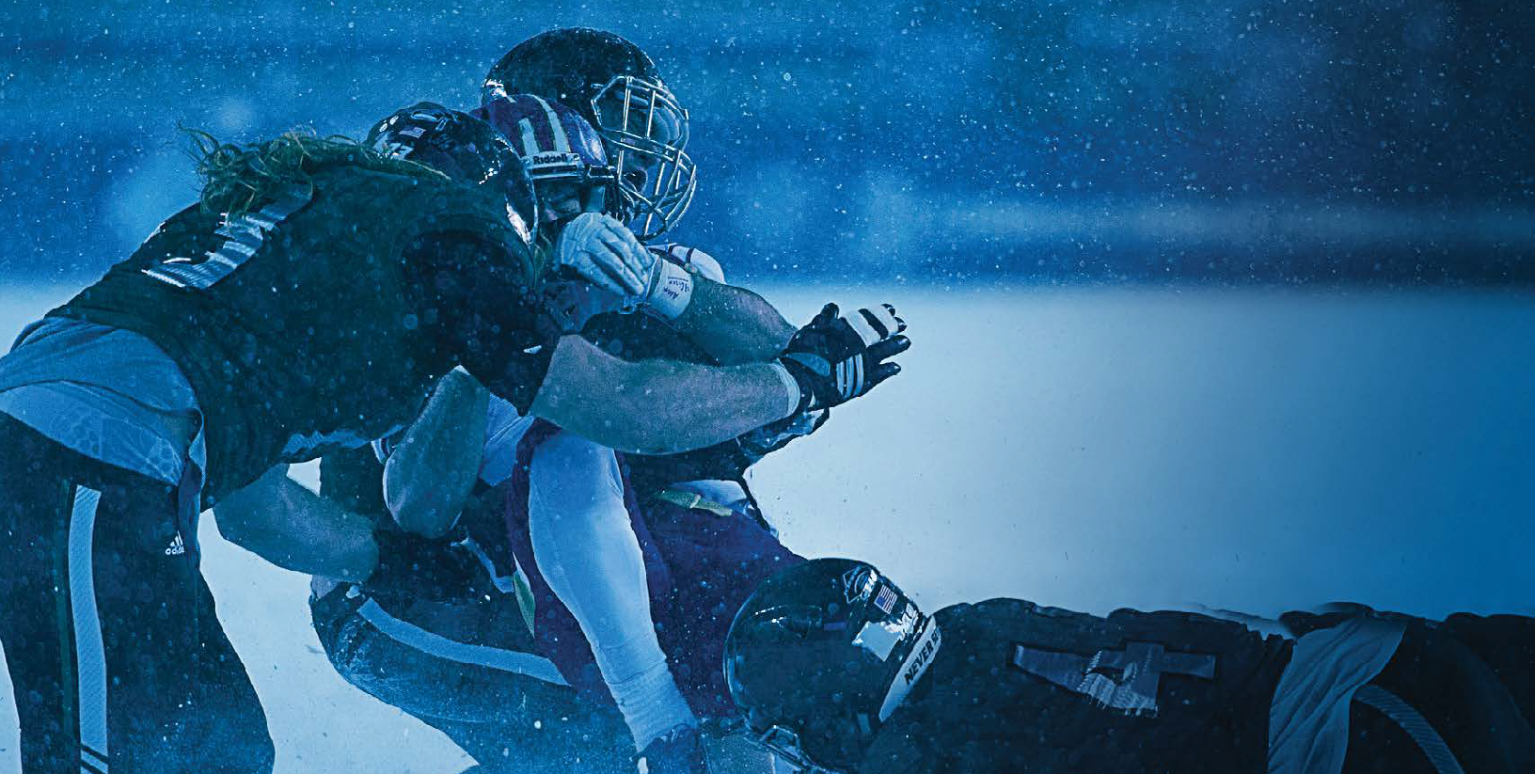

No two concussions are the same. New symptoms can appear hours or days after the initial impact. If you are unsure if you have a concussion, talk to your athletic trainer or team physician immediately.

NCAA | SPORT SCIENCE INSTITUTE | CONCUSSION SAFETY | WHAT STUDENT–ATHLETES NEED TO KNOW

What happens if I get a concussion and keep practicing or competing?
- Due to brain vulnerability after a concussion, an athlete may be more likely to suffer another
concussion while symptomatic from the first one.
- In rare cases, repeat head trauma can result in brain swelling, permanent brain damage or even death.
- Continuing to play after a concussion increases the chance of sustaining other injuries too, not just concussion.
- Athletes with concussion have reduced concentration and slowed reaction time. This means that you won’t be performing at your best.
- Athletes who delay reporting concussion take longer to recover fully.

What are the long-term effects of a concussion?
- We don’t fully understand the long-term effects of a concussion, but ongoing studies raise concerns.
- Athletes who have had multiple concussions may have an increased risk of degenerative brain disease and cognitive and emotional difficulties later in life.

CONCUSSION TIMELINE

What do I need to know about repetitive head impacts?
- Repetitive head impacts mean that an individual has been exposed to repeated impact forces to the head.
These forces may or may not meet the threshold of a concussion.
- Research is ongoing but emerging data suggest that repetitive head impact also may be harmful and place a student-athlete at an increased risk of neurological complications later in life.

Did you know?
- NCAA rules require that team physicians and athletic trainers manage your concussion and injury recovery independent of coaching staff, or other non-medical, influence.
- We’re learning more about concussion every day. To find out more about the largest concussion study ever conducted, which is being led by the NCAA and U.S. Department of Defense, visit ncaa.org/concussion.

Baseline Testing
Balance, cognitive and neurological tests that help medical staff manage and diagnose a concussion.

Concussion
If you show signs of a concussion, NCAA rules require that you be removed from play and medically evaluated.

Recovery
Your school has a concussion management plan, and team physicians and athletic trainers are required to follow that plan during your recovery.

Return to Learn
Return to school should be done in a step-by-step progression in
which adjustments are made as needed to manage your symptoms.

Return to Play
Return to play only happens after you have returned to your preconcussion baseline and you’ve gone
through a step-by- step progression of increasing activity.

For more information, visit ncaa.org/concussion.
NCAA is a trademark of the National Collegiate Athletic Association.

A FAct Sheet For Student-AthleteS

SICKLE CELL TRAIT

What is sickle cell trait?
sickle cell trait is not a disease. Sickle cell trait is the inheritance of one gene for sickle hemoglobin and one for normal hemoglobin. Sickle cell trait will not turn into the disease. Sickle cell trait is a life-long condition that will not change over time.
 During intense exercise, red blood cells containing the sickle hemoglobin can change shape from round to quarter-moon, or “sickle.”
 Sickled red cells may accumulate in the bloodstream during intense exercise, blocking normal blood flow to the tissues and muscles.
 During intense exercise, athletes with sickle cell trait have experienced significant physical distress, collapsed and even died.
 Heat, dehydration, altitude and asthma can increase the risk for and worsen complications associated with sickle cell trait, even when exercise is not intense.
 Athletes with sickle cell trait should not be excluded from participation as precautions can be put into place.

Do you knoW if you have sickle cell trait?

People at high risk
for having sickle cell trait are those whose ancestors come from Africa, South or
Central America, India, Saudi Arabia and Caribbean and Mediterranean countries.
 Sickle cell trait occurs in about 8 percent of the U.S. African-American population, and between one in 2,000 to one in 10,000 in the Caucasian population.
 Most U.S. states test at birth, but most athletes with sickle cell trait don’t know they have it.
 The NCAA recommends that athletics departments confirm the sickle cell trait status in all student-athletes.
 Knowledge of sickle cell trait status can be a gateway to education and simple precautions that may prevent collapse among athletes with sickle cell trait, allowing you to thrive in your sport.

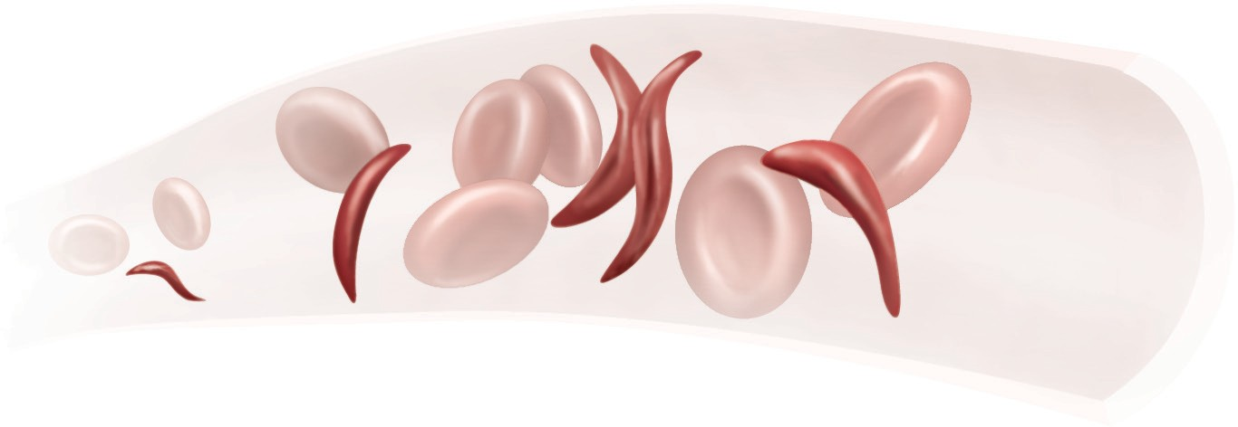
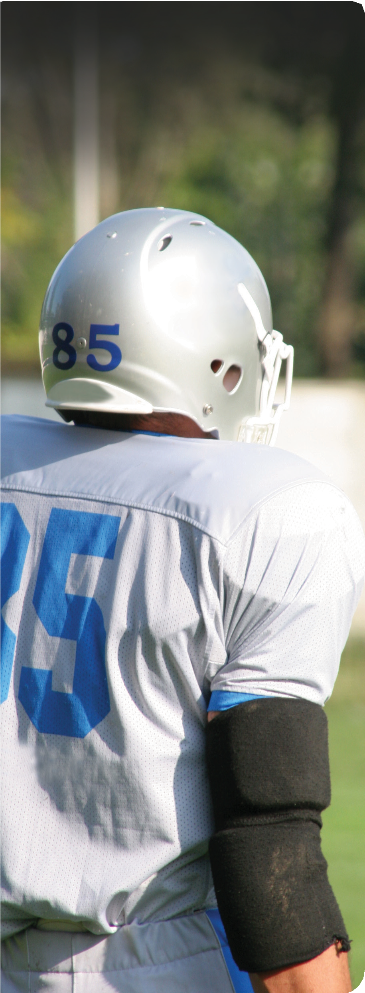
hoW can i Prevent a collaPse?
 Know your sickle cell trait status.
 Engage in a slow and gradual preseason conditioning regimen.
 Build up your intensity slowly while training.
 Set your own pace. Use adequate rest and recovery between repetitions, especially during “gassers” and intense station or “mat” drills.
 Avoid pushing with all-out exertion longer than two to three minutes without a rest interval or a breather.
 If you experience symptoms such as muscle pain, abnormal weakness, undue fatigue or breathlessness, stop the activity immediately and notify your athletic trainer and/or coach.
 Stay well hydrated at all times, especially in hot and humid conditions.
 Avoid using high-caffeine energy drinks or supplements, or other stimulants, as they may contribute to dehydration.

 Maintain proper asthma management.
 Refrain from extreme exercise during acute illness, if feeling ill, or while experiencing a fever.
 Beware when adjusting to a change in altitude, e.g., a rise in altitude of as little as 2,000 feet. Modify your training and request that supplemental oxygen be available to you.
 Seek prompt medical care when experiencing unusual physical distress.
For more information and resources, visit www.NCAA.org/health-safety

