Peer Tutoring

How to Schedule a Virtual Tutoring Appointment

1. Navigate to the Starfish site by using the “For Students” dropdown menu on the Trinity page:

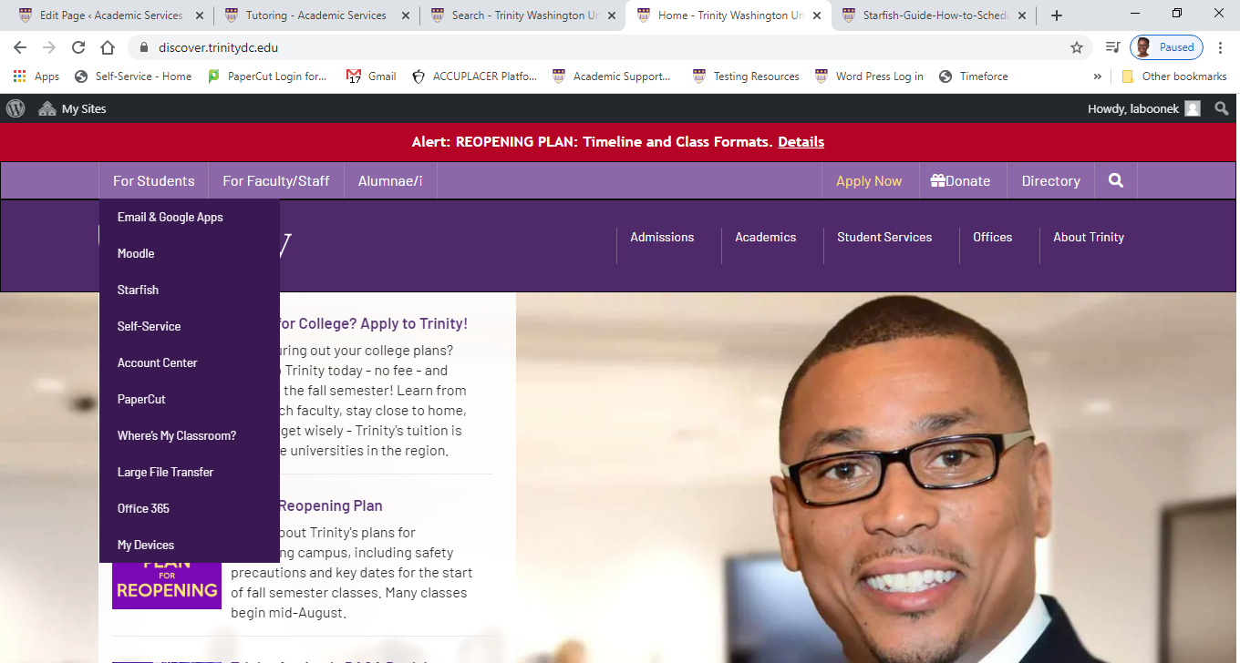

1. Login to Starfish by entering your username and password:

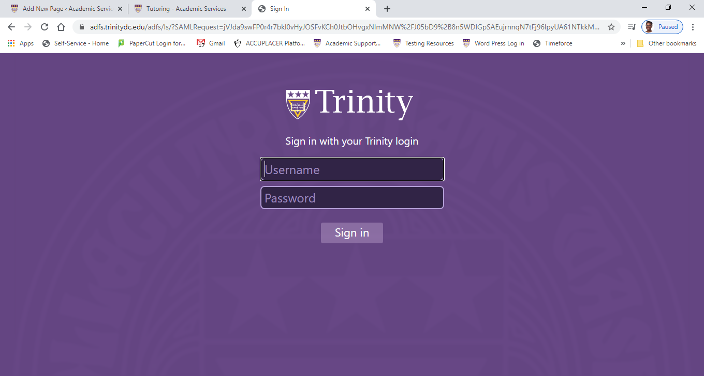

1. Under “Your Connections” you will see “My Success Network” where different services are listed. Select “Tutoring”

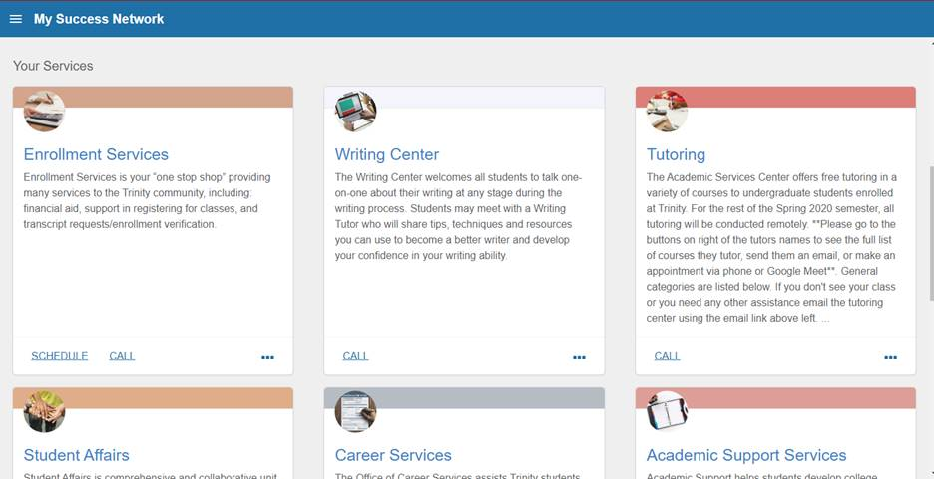

1. The Tutoring page lists the peer tutors. Click the radio button next to each tutor’s name to:

* View their profile to see what courses they tutor
* Send them an email
* Schedule a tutoring appointment

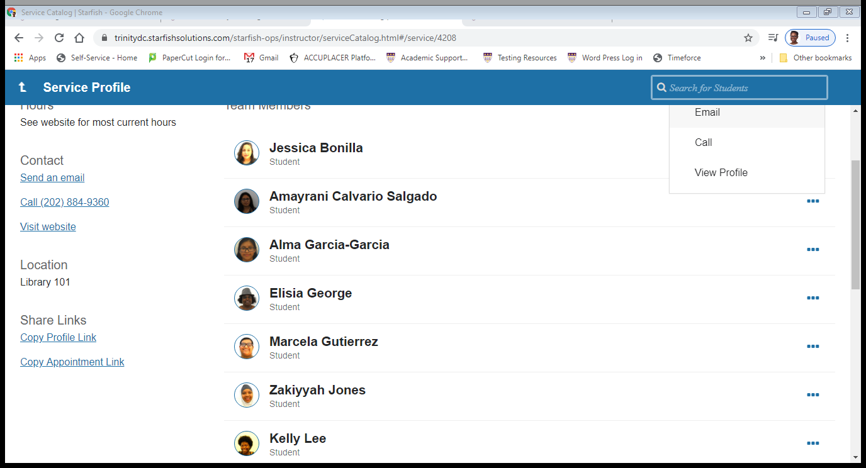

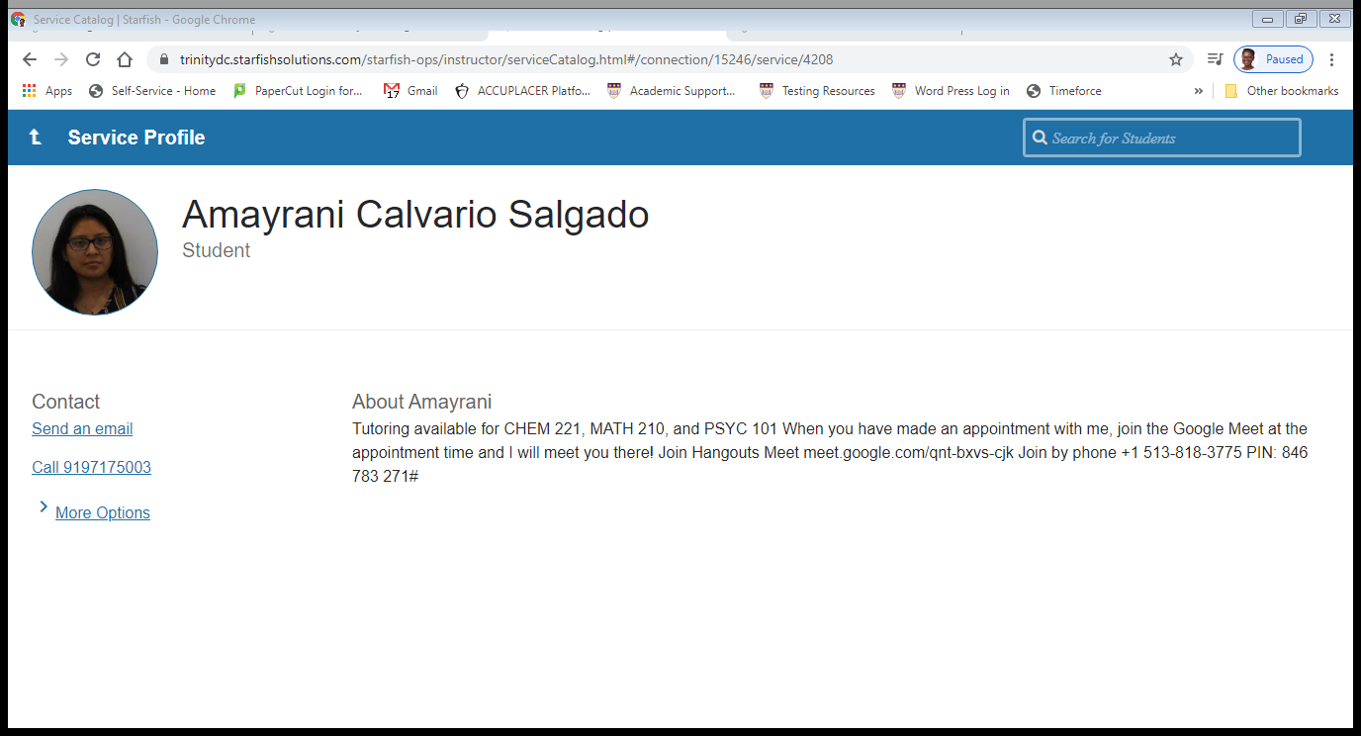

1. To schedule an appointment
   * Use the button in the tutor’s profile

OR

* + Click schedule, then tutor, and follow the prompts